Shape Drawer

Running at first, program look like:

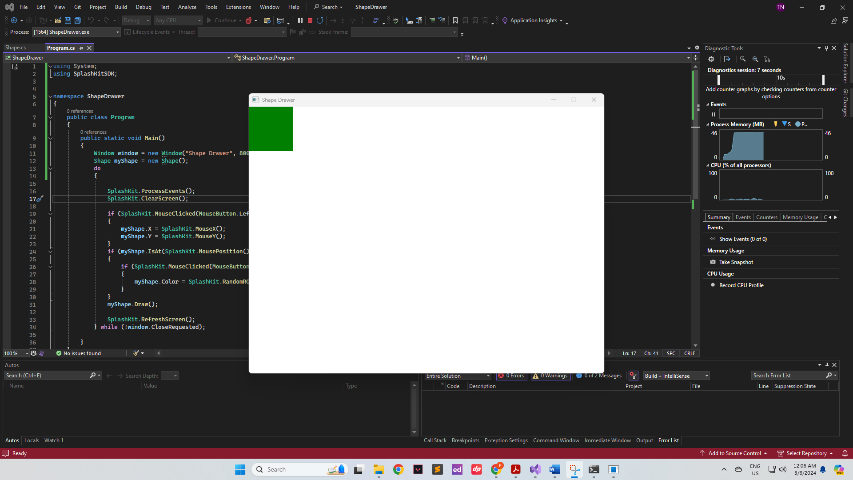

When left-clicking to another place inside the window:

When right-click inside the green square(change to another random color):

